**Day-67 practice (26/11/2024)**

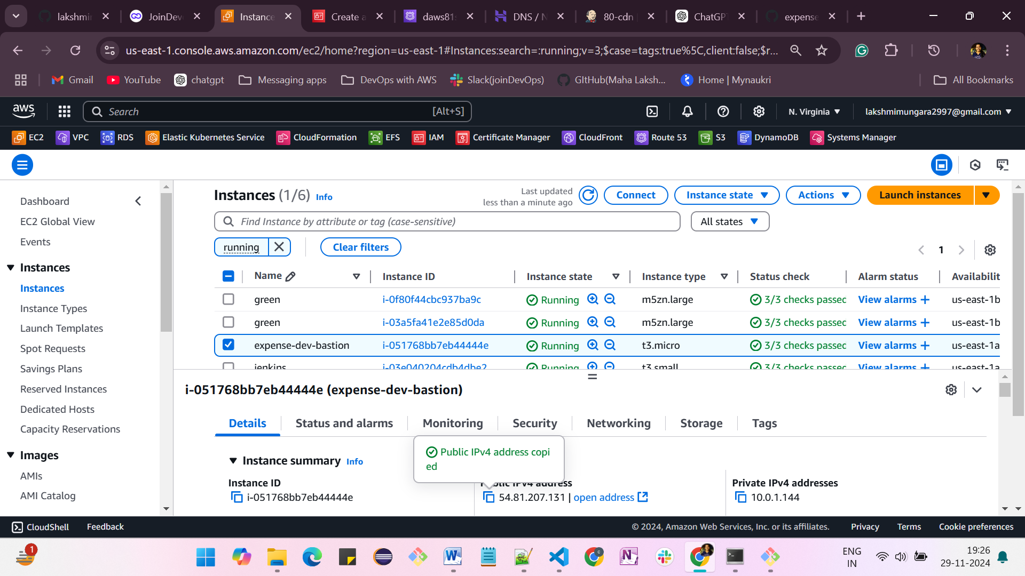

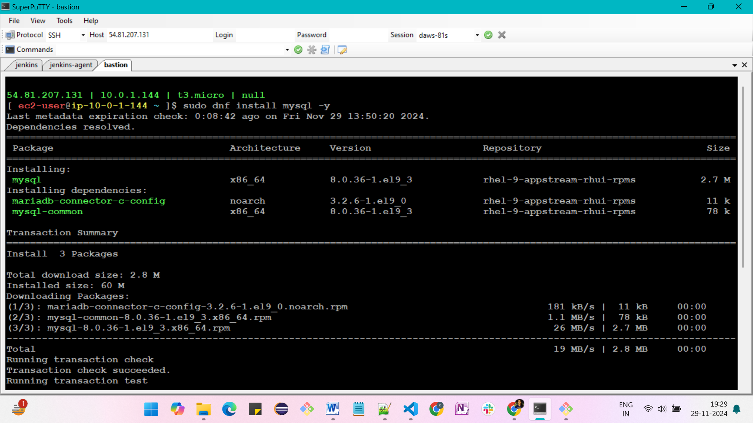

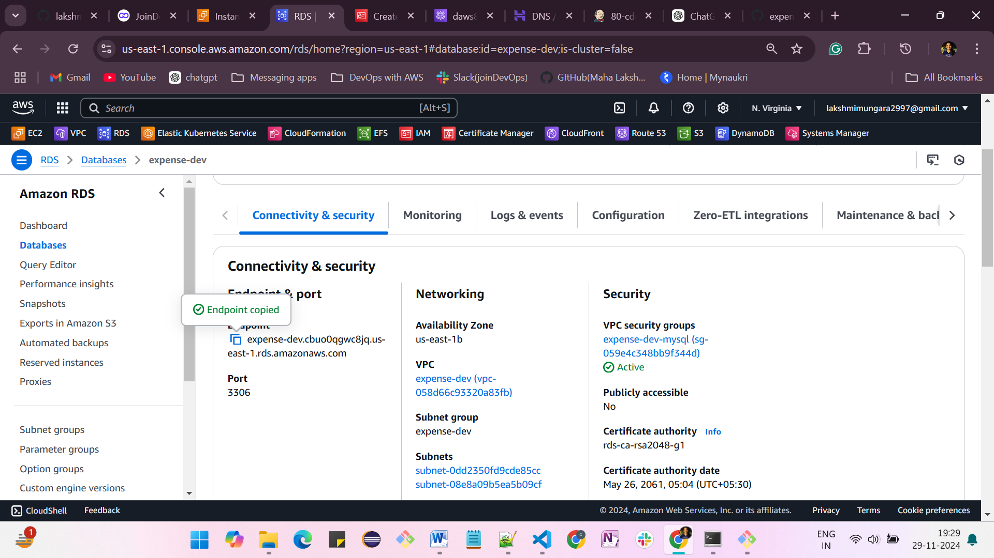

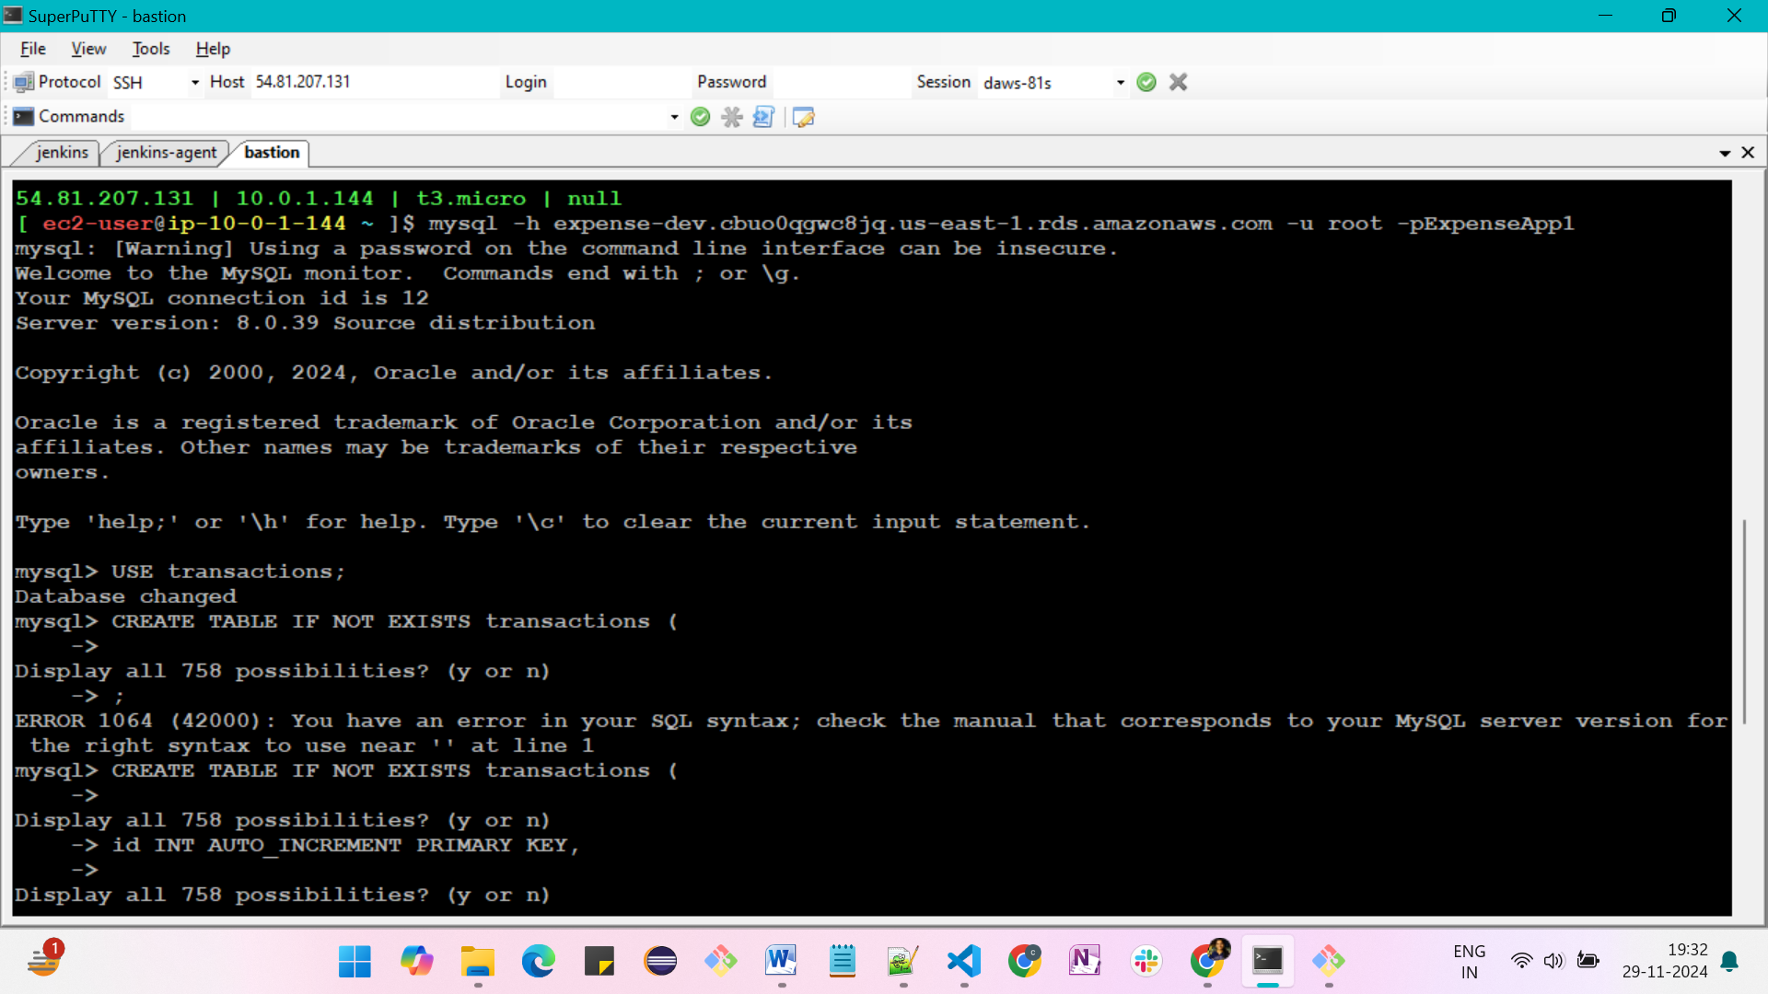

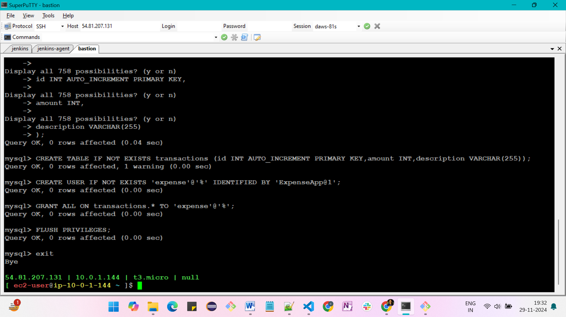

* mysql -h expense-dev.cbuo0qgwc8jq.us-east-1.rds.amazonaws.com -u root -pExpenseApp1
* USE transactions;
* CREATE TABLE IF NOT EXISTS transactions (id INT AUTO_INCREMENT PRIMARY KEY,amount INT,description VARCHAR(255));
* CREATE USER IF NOT EXISTS 'expense'@'%' IDENTIFIED BY 'ExpenseApp@1';
* GRANT ALL ON transactions.* TO 'expense'@'%';
* FLUSH PRIVILEGES;
* exit
* aws configure
* aws eks update-kubeconfig --region us-east-1 --name expense-dev

Kubectl installation

======================

* sudo curl -O https://s3.us-west-2.amazonaws.com/amazon-eks/1.31.0/2024-09-12/bin/linux/amd64/kubectl
* sudo chmod +x ./kubectl
* sudo mv kubectl /usr/local/bin/kubectl
* kubectl version
* kubectl get nodes
* kubectl create namespace expense

eksctl installation

======================

* + ARCH=amd64
  + PLATFORM=$(uname -s)_$ARCH
  + curl -sLO "https://github.com/eksctl-io/eksctl/releases/latest/download/eksctl_$PLATFORM.tar.gz"
* # (Optional) Verify checksum
  + curl -sL "https://github.com/eksctl-io/eksctl/releases/latest/download/eksctl_checksums.txt" | grep $PLATFORM | sha256sum --check
  + tar -xzf eksctl_$PLATFORM.tar.gz -C /tmp && rm eksctl_$PLATFORM.tar.gz
  + sudo mv /tmp/eksctl /usr/local/bin
  + curl -o iam-policy.json https://raw.githubusercontent.com/kubernetes-sigs/aws-load-balancer-controller/v2.10.0/docs/install/iam_policy.json
  + aws iam create-policy \

--policy-name AWSLoadBalancerControllerIAMPolicy \

--policy-document file://iam-policy.json

* + eksctl create iamserviceaccount \

--cluster=expense-dev \

--namespace=kube-system \

--name=aws-load-balancer-controller \

--attach-policy-arn=arn:aws:iam::169810528182:policy/AWSLoadBalancerControllerIAMPolicy \

--override-existing-serviceaccounts \

--region us-east-1 \

--approve

helm installation

=====================

* + helm repo add eks https://aws.github.io/eks-charts
  + helm install aws-load-balancer-controller eks/aws-load-balancer-controller \

-n kube-system \

--set clusterName=expense-dev \

--set serviceAccount.create=false \

--set serviceAccount.name=aws-load-balancer-controller

* + kubectl get pods -n kube-system

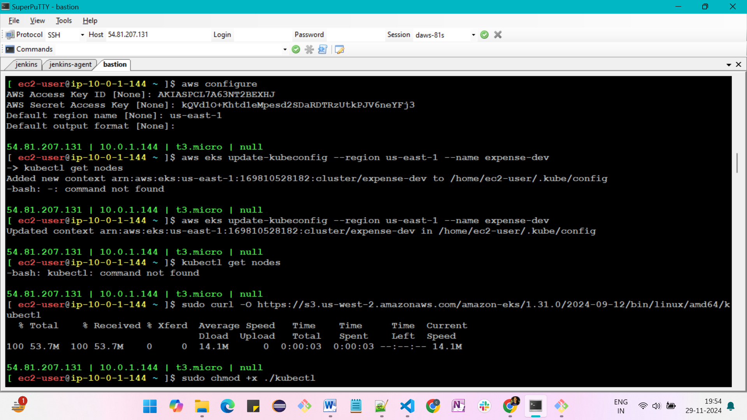

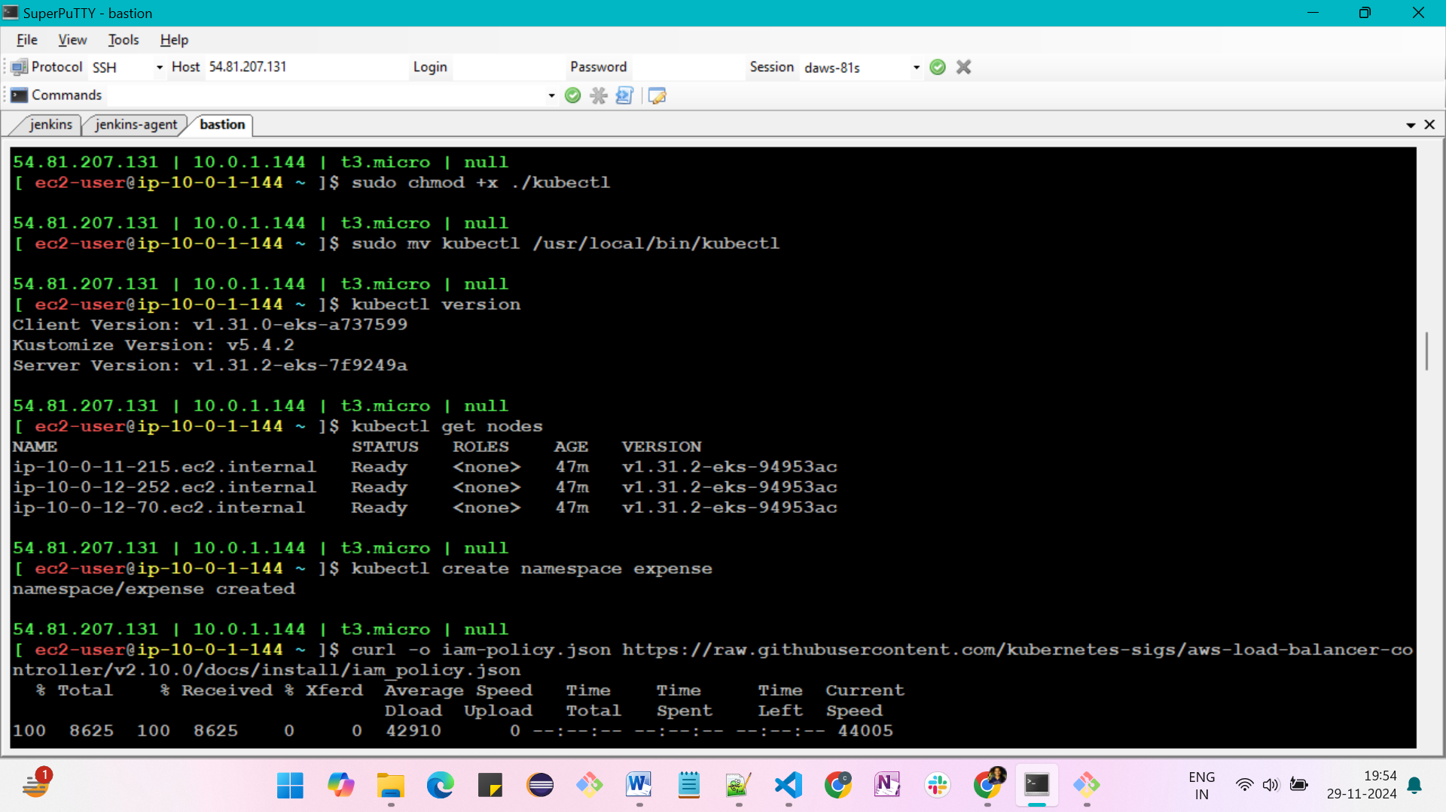

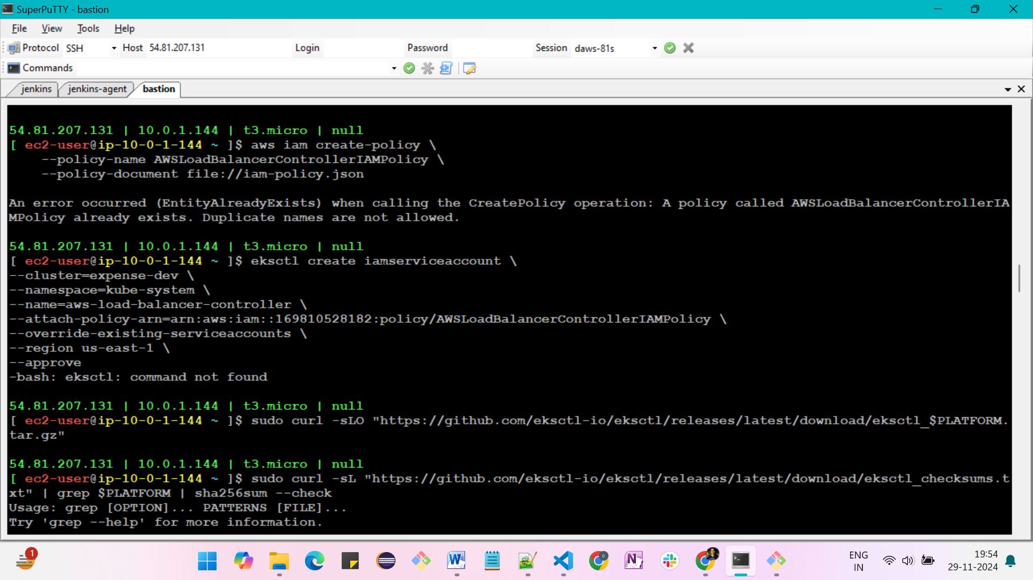

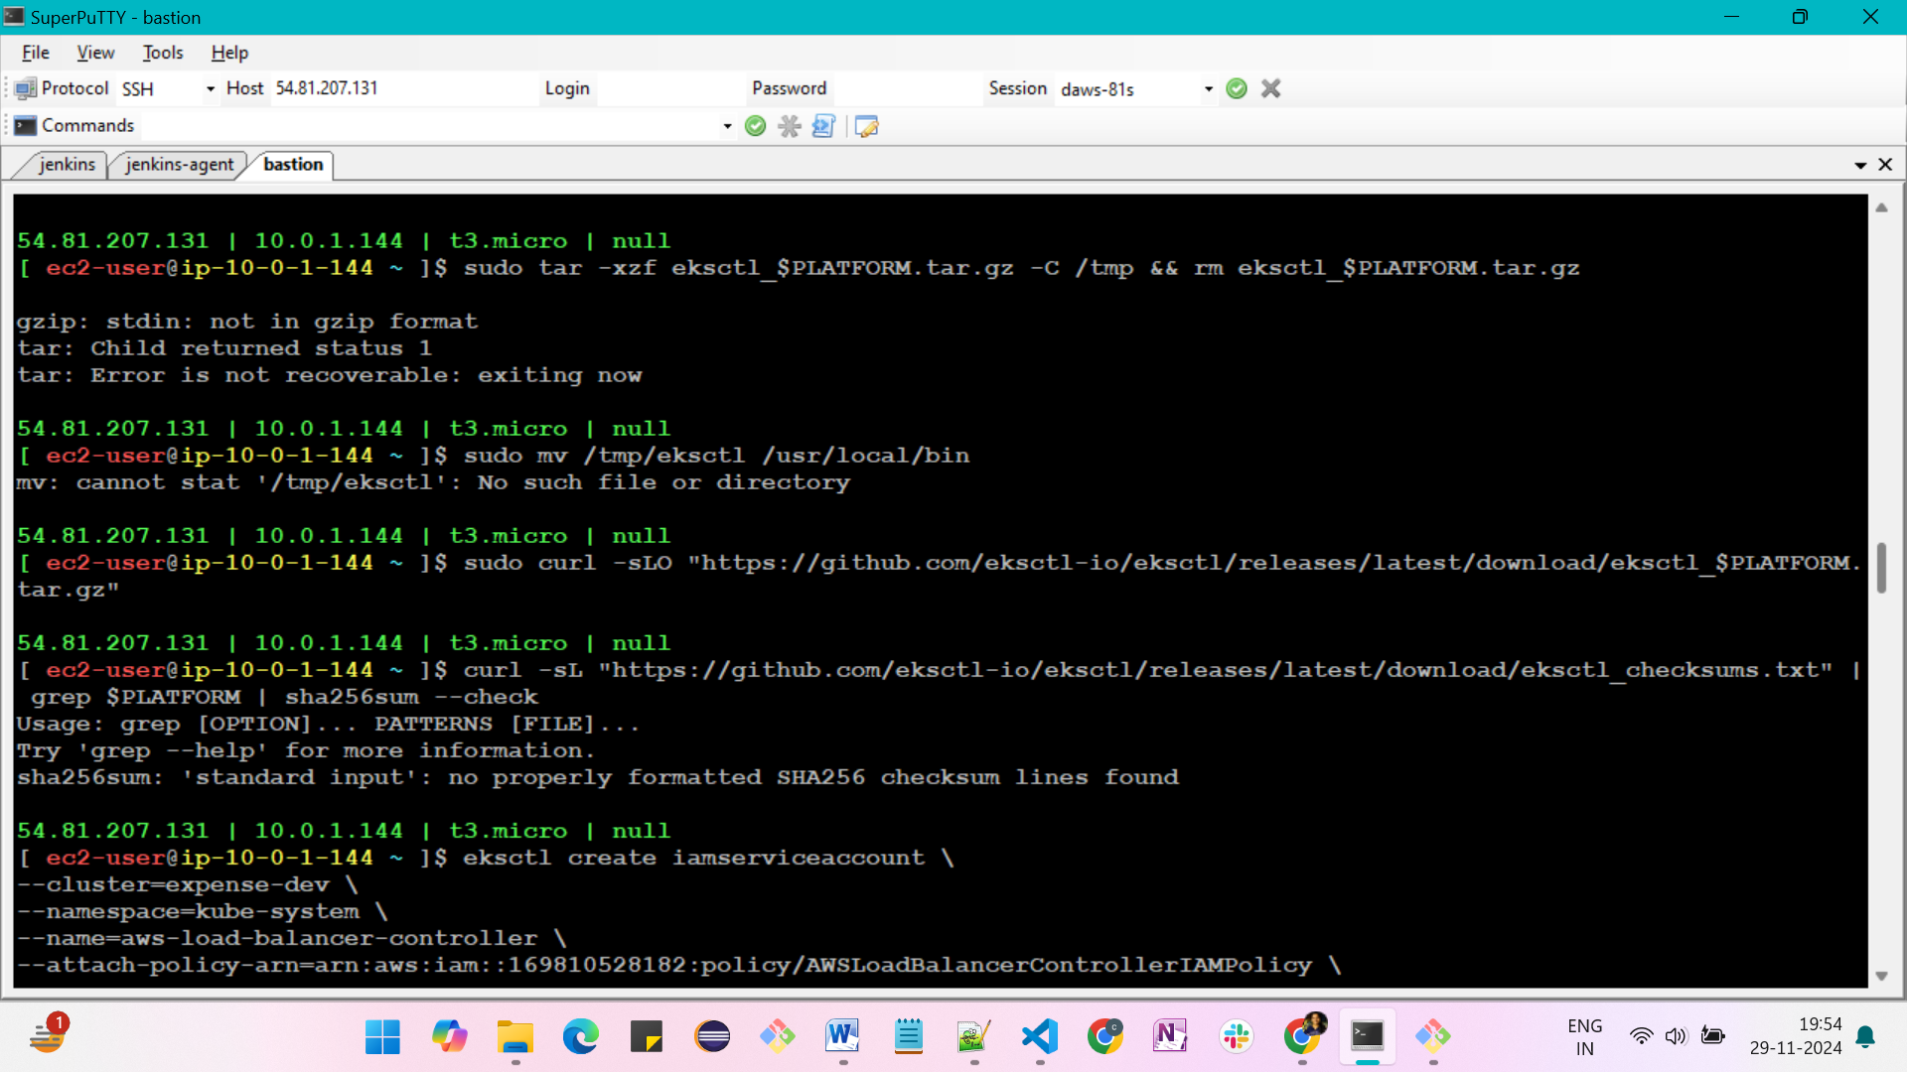

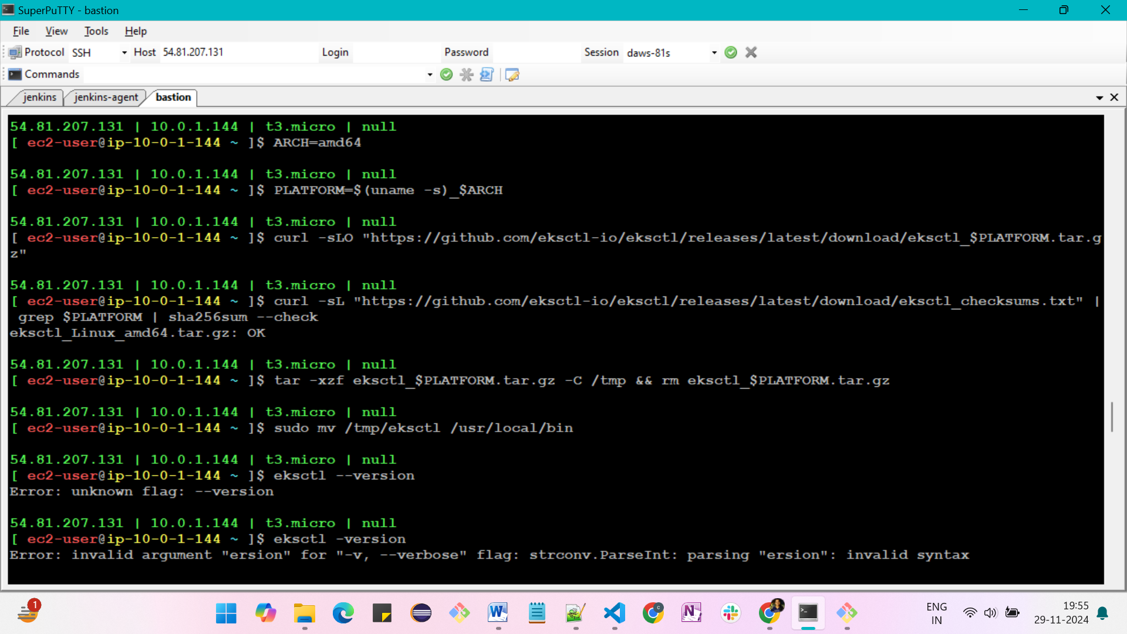

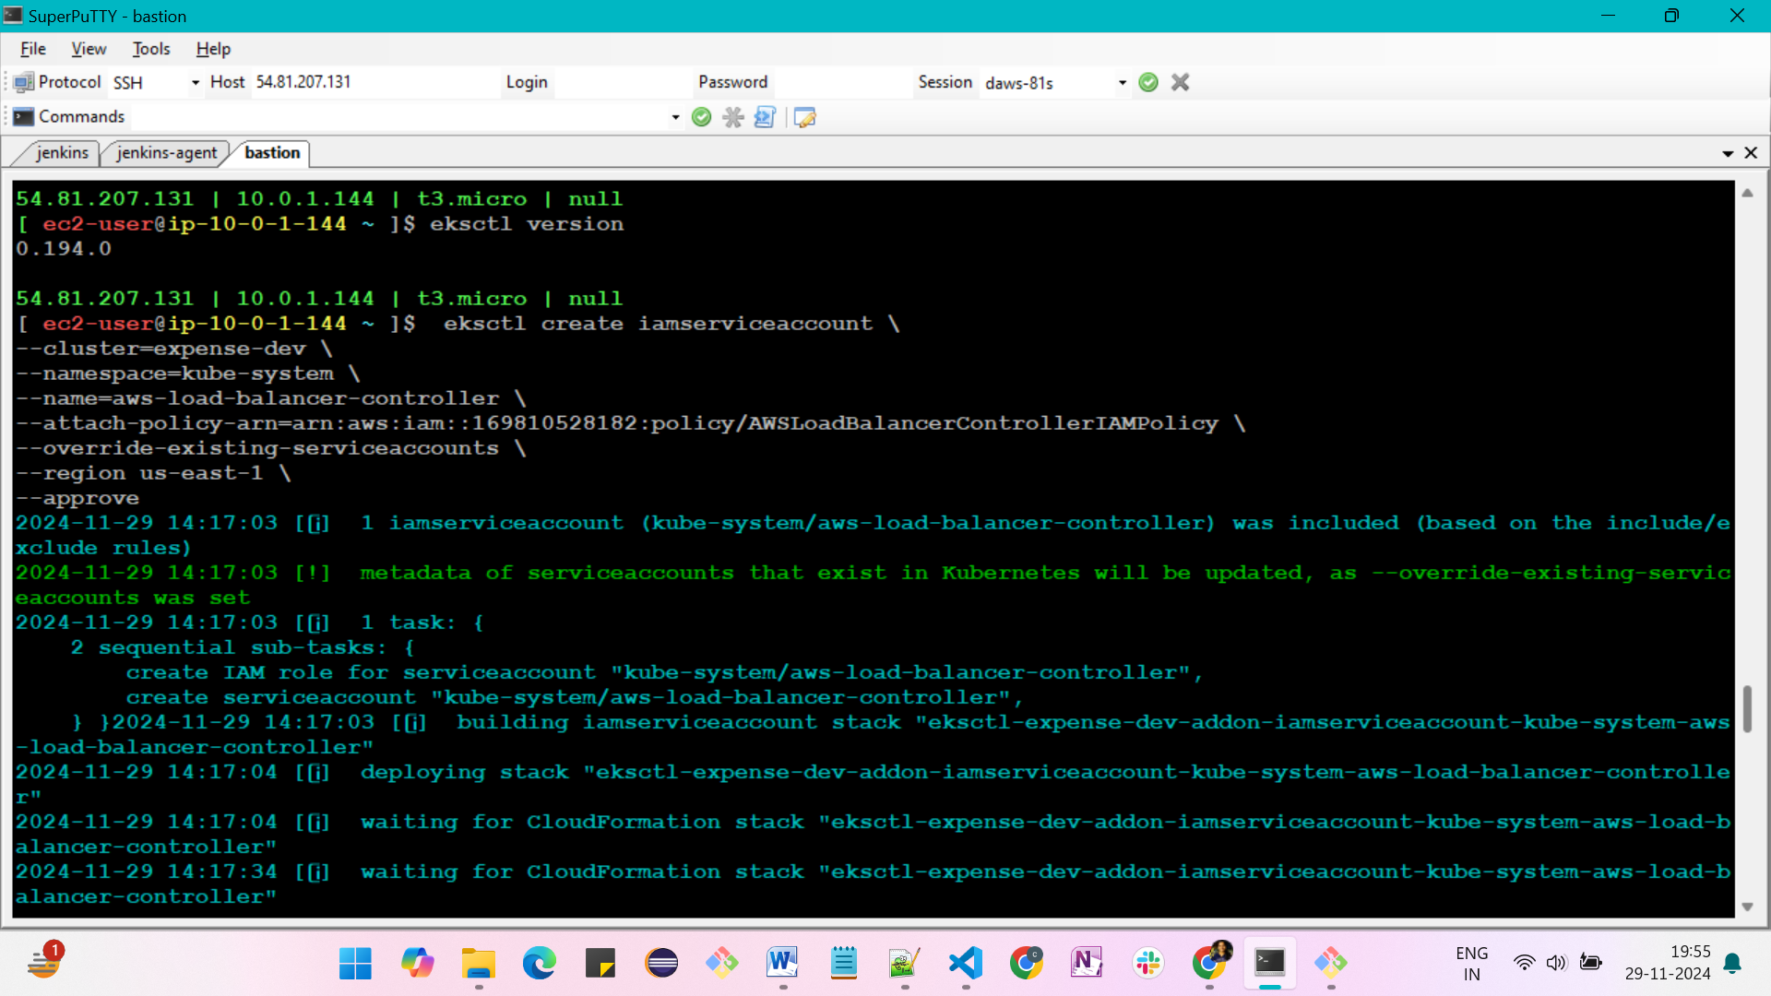

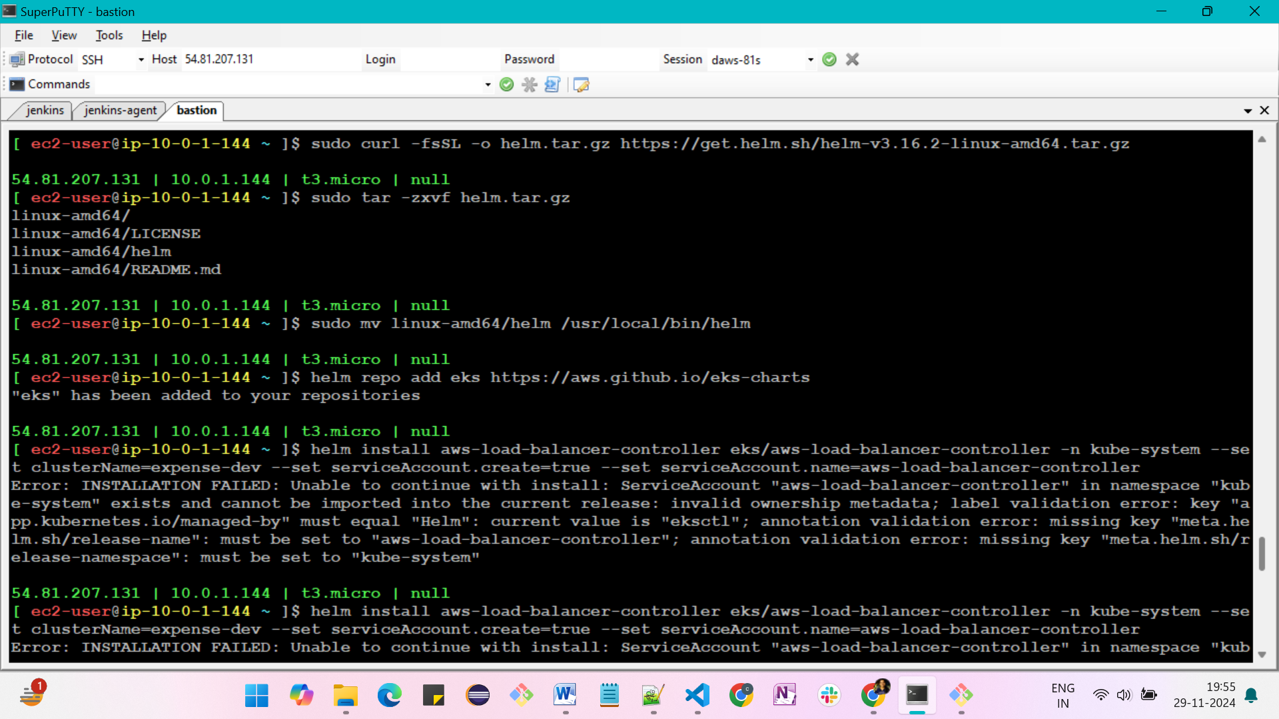

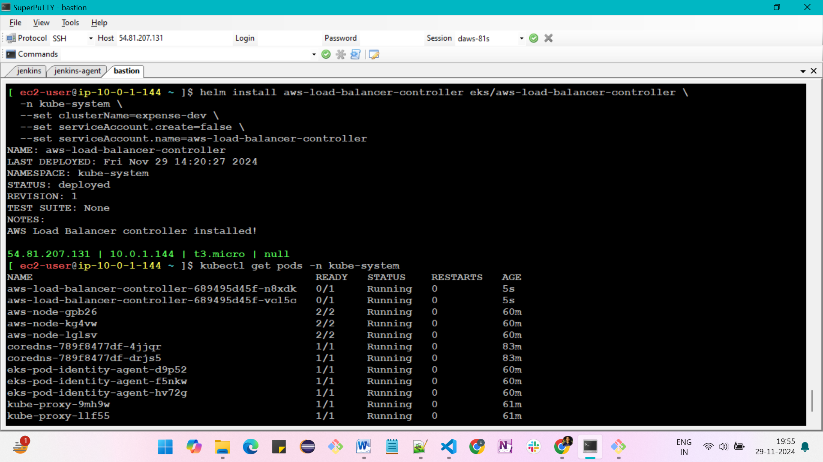

In backend folder

